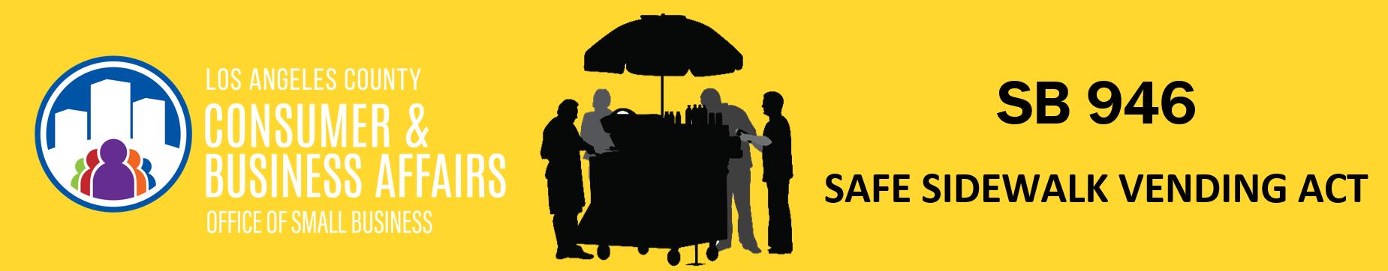
EMAIL TEMPLATE FOR SIDEWALK VENDORS
SUBJECT: NEW Safe Sidewalk Vending Act - What does it mean for you?
On September 17, 2018 the Governor signed SB 946, which is also known as the Safe Sidewalk Vending Act. This law ends the criminalization of sidewalk vending and allows local authorities, such as cities and counties, to develop their own rules and regulations. The Los Angeles County Department of Consumer and Business Affairs (DCBA) has provided the information below about SB 946.
Who does SB 946 apply to?
A “sidewalk vendor” is a person who sells food or merchandise on a sidewalk or pedestrian path. SB 946 does not apply to food trucks or anything with a motor.
Do vendors still have to comply with other sidewalk vending laws?
Yes. Although SB 946 ends criminalization of sidewalk vending, vendors must still comply with city, County, and state sidewalk vending laws. For example, all food vendors must comply with State laws like the California Retail Food Code, which requires food vendors to obtain permits from the Department of Public Health. Many cities - including the City of Los Angeles, Pasadena, El Monte, Monrovia, Pico Rivera, Santa Clarita, West Covina, Norwalk, Newport Beach, South Gate, Monrovia, Huntington Beach, Calabasas, and Beverly Hills - have sidewalk vending laws. Vendors doing business in those cities should comply with those sidewalk vending laws. Vendors must comply with a county’s sidewalk vending laws when conducting business in an unincorporated area. Los Angeles County is currently developing sidewalk vending laws, which will apply to vendors in unincorporated areas of Los Angeles County.
What happens if a sidewalk vendor violates sidewalk vending laws?
Sidewalk vendors cannot be arrested or criminally charged for violating a sidewalk vending law. However, if a vendor violates a city or county sidewalk vending law, they can receive an administrative fine. In addition, vendors can be arrested and criminally charged for violating other applicable laws. For example, vendors can still be arrested for trespassing if they vend on private property owned by others without the property owner’s permission. If you have a misdemeanor or infraction conviction for sidewalk vending, you may submit a petition to the trial court to request that the criminal conviction be dismissed.
Local authorities CAN’T
- Require sidewalk vendors to operate in a specific area, unless the local authority is restricting vending to protect the community’s health, safety, or welfare.
- Require vendors to ask permission from businesses or anyone besides the government.
- Prohibit sidewalk vendors from operating in public parks, unless the park has a concession agreement, or the park is restricting vending to protect the community’s health, safety, or welfare.
- Restrict the number of sidewalk vendors, unless the city or county must restrict the number of vendors to protect the community’s health, safety, or welfare.
Local authorities CAN
- Limit hours of operation.
- Prohibit stationary sidewalk vending in residential areas.
- Prohibit sidewalk vending near farmers’ markets, swap meets, and temporary special permit areas (for example, filming, parades, or outdoor concerts).
- Require vendors to comply with the Americans with Disability Act (for example, vendors cannot block curb ramps).
- Require a permit or license.
- Request certain information about the business (name and mailing address of vendor, type of sale).
DCBA has detailed information on their website; you can stay up to date on the Safe Sidewalk Vending Act here: http://dcba.lacounty.gov/sidewalkvending
For any questions about the Safe Sidewalk Vending Act or other sidewalk vending law, contact the Los Angeles County Department of Consumer and Business Affairs at sidewalkvending@dcba.lacounty.gov.

